2. SQL Exercise – Index
Hands-on in this document
create database salesdb;
use salesdb;
create table customers(
customerid int primary key,
name varchar(100),
region varchar(50)
);
create table products(
productid int primary key,
productname varchar(100),
category varchar(50),
price decimal(10,2)
);
create table orders(
orderid int primary key,
customerid int,
orderdate date,
foreign key (customerid) references customers(customerid)
);
create table orderdetails
(
orderdetailid int primary key,
orderid int,
productid int,
quantity int,
foreign key (orderid) references orders(orderid),
foreign key (productid) references products(productid)
);
insert into customers(customerid,name,region) values
(1, 'Alice', 'North'),
(2, 'Bob', 'South'),
(3, 'Charlie', 'East'),
(4, 'David', 'West');

insert into products(productid,productname,category,price) values
(1, 'Laptop', 'Electronics', 1200.00),
(2, 'Smartphone', 'Electronics', 800.00),
(3, 'Tablet', 'Electronics', 600.00),
(4, 'Headphones', 'Accessories', 150.00);

insert into orders(orderid,customerid,orderdate)values
(1, 1, '2023-01-15'),
(2, 2, '2023-02-20'),
(3, 3, '2023-03-25'),
(4, 4, '2023-04-30');

insert into orderdetails(orderdetailid,orderid,productid,quantity) values
(1, 1, 1, 1),
(2, 2, 2, 2),
(3, 3, 3, 1),
(4, 4, 4, 3);
--------------------------------------------
Exercise 1: Non-Clustered Index
--------------------------------------------
-- Before Index Creation--
select *
from products
where productname = 'Laptop';

-- Create Non-Clustered Index--
create index IX_products_productname
on products(productname);
-- After Index Creation--
select *
from products
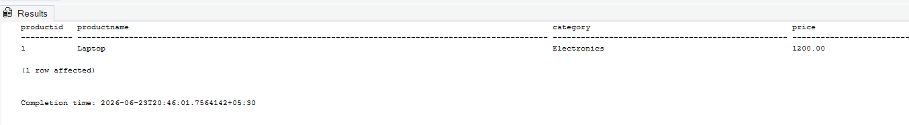
where productname = 'Laptop';

-------------------------------------
Exercise 2: Clustered Index
-------------------------------------
-- Before Index Creation—
select *
from orders
where orderdate = '2023-01-15';
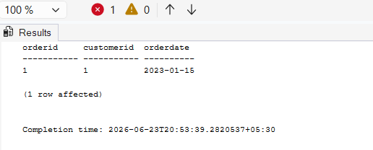

-- After Index Creation--
-- Create Clustered Index--
-- SQL Server Only--

exec sp_help 'orders';
alter table orderdetails
drop constraint FK__orderdeta__order__6383C8BA;
alter table Orders
drop constraint PK__orders__080E37753F5AFCA7;
sp_helpindex orders;
drop index IX_orders_orderdate
on orders;
create clustered index IX_Orders_OrderDate
on orders(orderdate);
select *
from orders
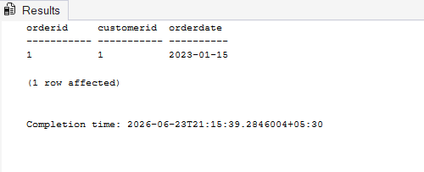
where orderdate = '2023-01-15';

-------------------------------------
Exercise 3: Composite Index
-------------------------------------
-- Before Index Creation—

select *
from orders
where customerid = 1
and orderdate = '2023-01-15';
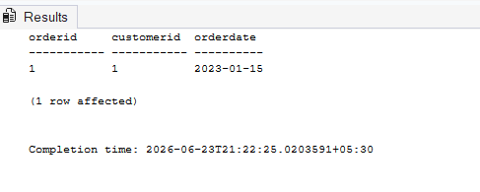

-- Create Composite Index--
create index IX_Orders_CustomerID_OrderDate
on orders(customerid, orderdate);
-- After Index Creation--
select *
from orders
where customerid = 1
and orderdate = '2023-01-15';
